**PROBLEM:**

**A program of Numerical Differentiation where F(x)= -0.1x4 -0.15x3-0.5x2-0.25x+1.2**

**OBJECTIVE:**

To study how to Differentiate a given function using Forward,Backward & Centre Dfferences

**PROBLEM CODE:**

#include <bits/stdc++.h>

using namespace std;

double f1x;

double fofx(double x)

{

return -(.1)*x*x*x*x-(.15)*x*x*x-(.5)*x*x -(.25)*x+1.2;

}

double fdfx(double x)

{

return -(.4)*x*x*x-(.45)*x*x-x-.25;

}

double error(double val)

{

double ans=(fabs(f1x-val)/f1x)*100;

return (ans>0)?ans: (ans)*(-1);

}

int main()

{

double x,fx,h,x0,x1,fd,bd,cd,Err1,Err2,Err3;

cout<<"Give the value of x & h "<<endl;

cin>>x>>h;

x0 = x-h;

x1 = x+h;

fx = fofx(x);

f1x = fdfx(x);

fd = (fofx(x1) - fx )/h;

bd = (fx-fofx(x0))/h;

cd = (fofx(x1) - fofx(x0) )/(2*h);

Err1 = error(fd);

Err2= error(bd);

Err3= error(cd);

cout<<"Value of x using Forward Difference : "<<fd<<" Error: "<<Err1<<"%"<<endl;

cout<<"Value of x of Backward Difference: "<<bd<<" Error: "<<Err2<<"%"<<endl;

cout<<"Value of x Central Difference : "<<cd<<" Error: "<<Err3<<"%"<<endl;}

**OUTPUT:**

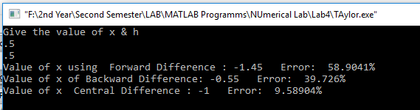

**DISCUSSION:**

Numerical differentiation is the process of finding the numerical value of a derivative of a given function at a given point.In the program we find out the first derivative of a given function using Forward Differences,backward differences & centre Differences.Among the formula,In Forward Differences the error rate is too high.Using Centre Differences The error rate suffuciently low.So,we can say that The Centre Differences is more efficient to find out The first derivative of a function.